

Multimedia University

CCP6124 Object Oriented Programming and Data Structures 2410

Lecture section: TC3L
Tutorial section: TT9L / T10L
Group number: 22
Group leader student name: Muhammad Faiz bin Ilyasa

Num | Student  ID | Student Name by  alphabetical order | Task Descriptions | Percentage (%)
1 | 1211111345 | Amar Arshad bin Ayub | Divided tasks accordingly, coded battlefield, linked list, destruction of robots and recovering of robots.
2 | 1221305940 | Haffy Rayyan bin Hairulazizi | In charge of the report, coded robot upgrade and linked list.
3 | 1211110730 | Manisha Farhana binti Mohammad Ibrahim Miah | Implemented pseudocode and UML, coded queues, destruction of robots and recovering of robots.
4 | 1221309435 | Muhammad Faiz bin Ilyasa | Acted as the leader and main programmer, fixed errors, coded different robot classes and input/output to file.
 |  |  | Total | 100%

Assignment Evaluation Criteria (40%)
Student 1
Student ID | 1211111345 | Total Score 40%
Student name | Amar Arshad bin Ayub
Task descriptions | Divided tasks accordingly, coded battlefield, linked list, destruction of robots and recovering of robots.

Student 2
Student ID | 1221305940 | Total Score 40%
Student name | Haffy Rayyan bin Hairulazizi
Task descriptions | In charge of the report, coded robot upgrade and linked list.

Student 3
Student ID | 1211110730 | Total Score 40%
Student name | Manisha Farhana binti Mohammad Ibrahim Miah
Task descriptions | Implemented pseudocode and UML, coded queues, destruction of robots and recovering of robots.

Student 4
Student ID | 1221309435 | Total Score 40%
Student name | Muhammad Faiz bin Ilyasa
Task descriptions | Acted as the leader and main programmer, fixed errors, coded different robot classes and input/output to file.

Assignment implementation (30%)
Criteria | Max | A1 | A2 | Mark
Q1. Design documentation, UML class diagram, two sample inputs and outputs or -30  - has UML class diagram + screenshots (inputs, outputs) + figures,  - has code segments + pseudocodes,  - accept & has explanations, good, great | 5 | * | * | ?
Q2. Initialization of a simulation, read input file and output initial of all robots, fixed seed integer for random functions | 1 | * | * | ?
Q3. Display and logging of the status of the battlefield of robots at each turn  - accept & has file output, good, great | 3 | * | * | ?
Q4. Display and logging of the robot actions and the status of each robot at each turn  - accept & has file output, good, great | 3 | * | * | ?
Q5. Implementation of the required 7 robot classes with OOP concepts +1 or I&P&OO -3 | 8 | * | * | ?
Q6. The algorithms used to optimize the actions of robots, optimize the two actions or -2  - has screenshots (inputs, outputs) + figures,  - has code segments + pseudocodes,  - accept & has explanations, good, great | 5 |  | * | ?
Q7. Design and implementation of data structures, linked list and queues or -2  - has linked list with screenshots (inputs, outputs) + figures + code segments + explanations + linked list to keep track robot actions during the simulation,  - has queues with screenshots (inputs, outputs) + figures + code segments + explanations + two queues to keep track of the destroyed and waiting robots,  - accept & has explanations, good, great | 5 |  | * | ?
Q8. Extra
Implementation of additional three robot classes | 3
Total | 33 => 30 |  |  | ?

Examined with the additional term test
Item  9. Questions added as part of the assignment (individual marks) |  | Maximum marks | Actual  Marks
- Student Name 1: Amar Arshad bin Ayub  - Student Name 2: Haffy Rayyan bin Hairulazizi  - Student Name 3: Manisha Farhana binti Mohamad Ibrahim Miah  - Student Name 4: Muhammad Faiz bin Ilyasa |  | 10 | ?1  ?2  ?3  ?4
Total |  | 40 | ?1  ?2  ?3  ?4

Additional Comments

Table of contents with page numbers and links

Assignment implementation (30%) 2
Table of contents with page numbers and links 4
Questions Section 5
Q1. [5] Design documentation, UML class diagram, two sample inputs and outputs 5
Q2. [1] Initialization of a simulation, read input file and output initial of all robots, fixed seed integer for random functions 8
Q3. [3] Display and logging of the status of the battlefield of robots at each turn 9
Q4. [3] Display and logging of the robot actions and the status of each robot at each turn 9
Q5. [8] Implementation of the required 7 robot classes with OOP concepts +1 or I&P&OO -3 16
Q6. [5] The algorithms used to optimize the actions of robots, optimize the two actions or -2 17
Q7. [5] Design and implementation of data structures, linked list and queues or -2 19
Question: How to compile, how to run the program 21

Questions Section

Q1. [5] Design documentation, UML class diagram, two sample inputs and outputs

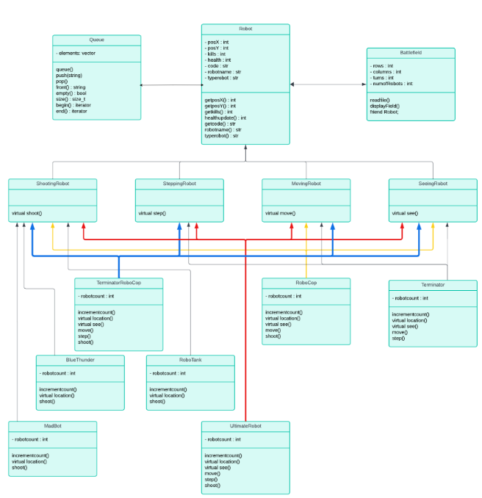

Sample 1 input file
filename: fileInput1.txt
/////
M by N: 10 15
turns: 300
robots: 7
RoboCop RC01_Star random random
Terminator T01_Alpha 1 2
TerminatorRoboCop TR01_Gamma 3 3
BlueThunder BT01_Beta 2 3
Madbot MB01_Kidd 3 6
RoboTank RT01_Jet 1 1
UltimateRobot UR01_Delta 7 7
/////

Sample 1 output file
filename: fileOutput1.txt
step by step screenshot outputs, output file, explanations
/////
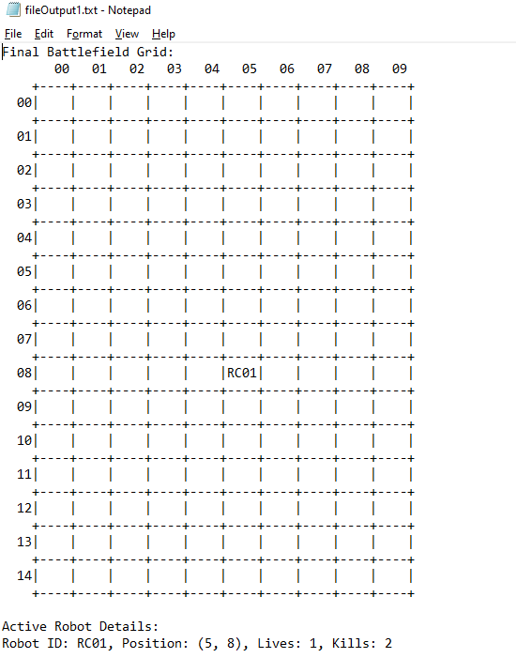

/////

Sample 2 input file
filename: fileInput2.txt
/////
M by N: 10 15
turns: 10
robots: 7
RoboCop RC01_Star random random
Terminator T01_Alpha 1 4
TerminatorRoboCop TR01_Gamma 3 3
BlueThunder BT01_Beta 3 4
Madbot MB01_Kidd 3 6
RoboTank RT01_Jet 8 9
UltimateRobot UR01_Delta 7 7
/////

Sample 2 output file
filename: fileOutput2.txt
step by step screenshot outputs, output file, explanations
/////
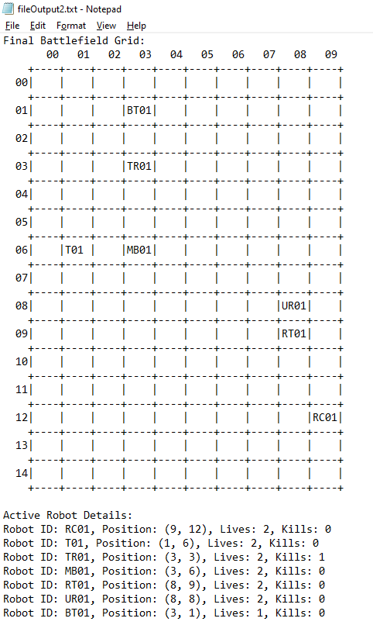

////
Q2. [1] Initialization of a simulation, read input file and output initial of all robots, fixed seed integer for random functions

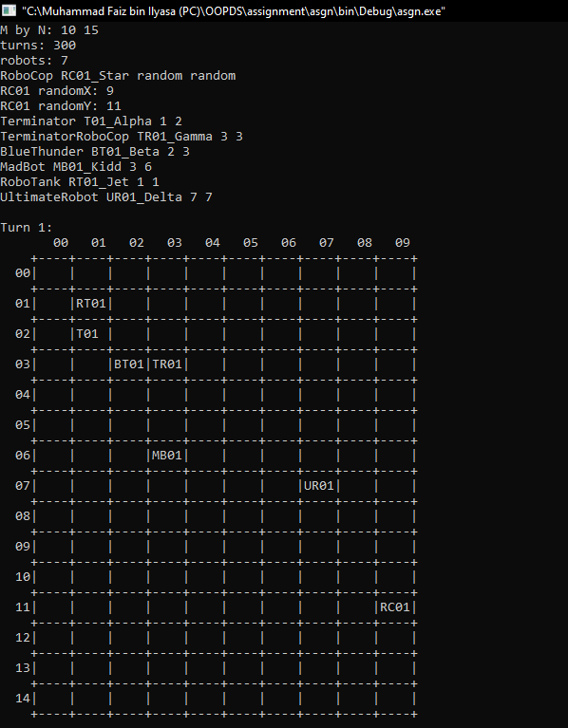

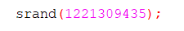

Q3. [3] Display and logging of the status of the battlefield of robots at each turn
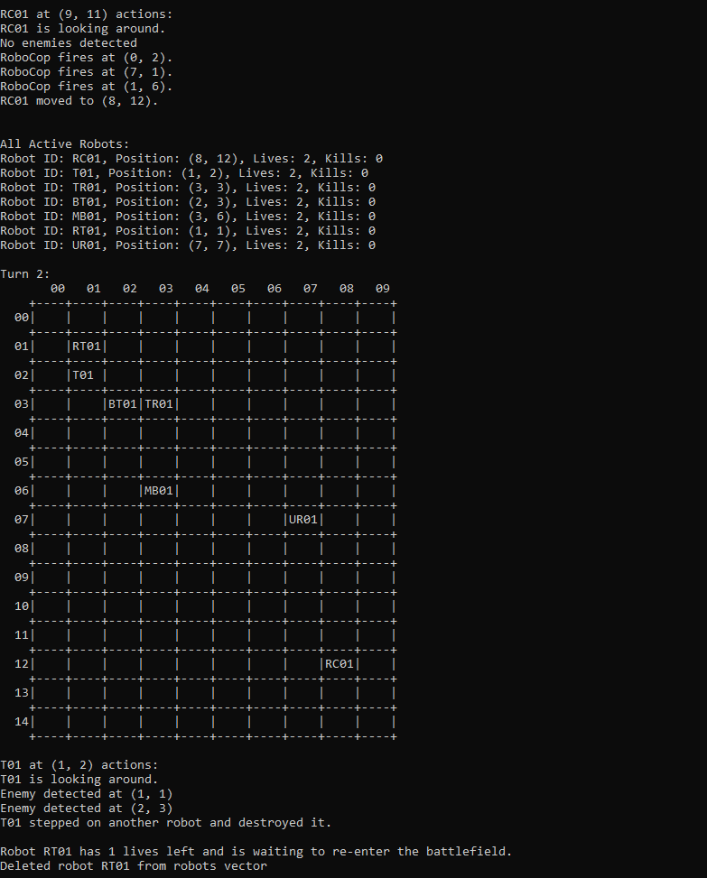

Q4. [3] Display and logging of the robot actions and the status of each robot at each turn

a. RoboCop: In each turn, this robot looks at its current position and decides on a move to one of its 8 neighboring locations. RoboCop cannot move to a location that contains another robot. It moves to one random location.
In the same turn, this robot fires (three times) at random positions in the battlefield.
This sequence is repeated for each turn. The maximum city block distance of firing should be set to 10 (i.e. for any fire (robotPositionX + x, robotPositionY + y), (x + y) is at most 10 at least 1).
If RoboCop fires a total of 3 robots, then it will be upgraded to be allowed to move to a location that contains another robot, thus stepping and killing that robot. This type of robot is called TerminatorRoboCop (see below).

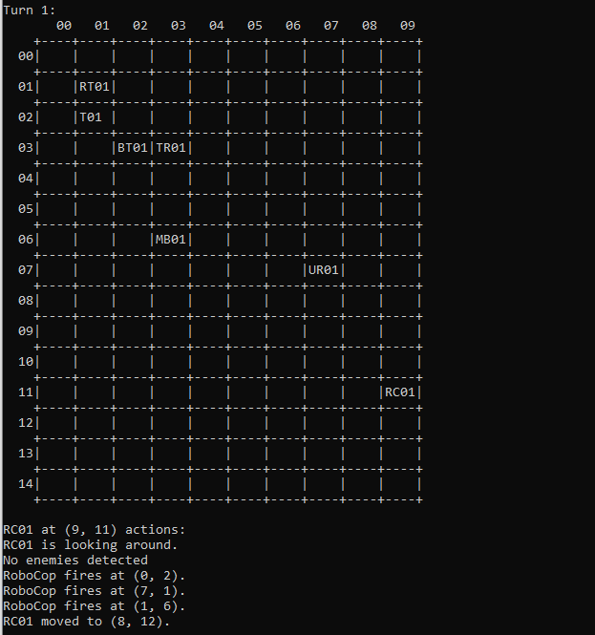

b. Terminator: In each turn, this robot looks at the immediate 8 neighborhoods (3x3 window centered at the robot position) and performs a move to one of the 8 neighbors. Thus, a Terminator will not fire at all and will terminate robots in its path. It will prefer locations which contain enemy robots.
If the Terminator kills a total of 3 other robots, then the Terminator will be upgraded to be allowed to fire in a similar way to a RoboCop fire, this type of robot will now become a TerminatorRoboCop as well.

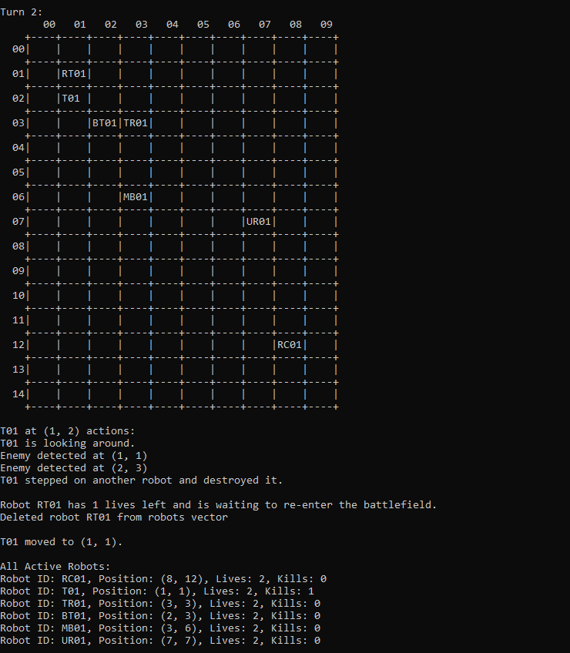

c. TerminatorRoboCop: This is either an upgraded RoboCop or an upgraded Terminator, it means it is a robot that can fire like RoboCop, and step on other robots like Terminator.
If the TerminatorRoboCop kills 3 other robots, it will be upgraded to UltimateRobot (see below).
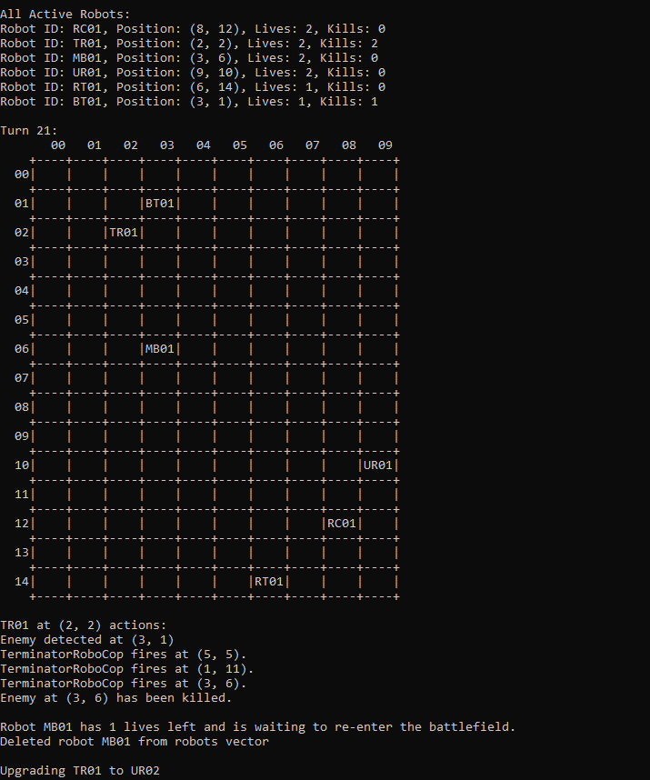

d. BlueThunder: This robot does not move and cannot look. It fires at only one of its immediate 8 neighboring cells surrounding it. In each turn, the target location to fire is not random. The sequence of firing is such that it starts from the location up and continues with a new location clockwise in each following turn.
If BlueThunder fires a total of 3 other robots, it will be upgraded to Madbot.
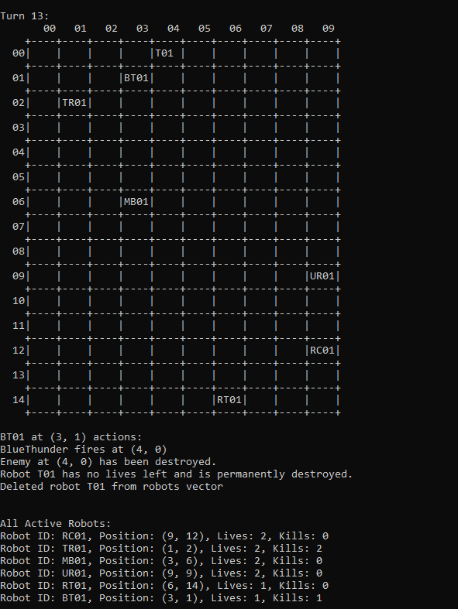

e. Madbot: This robot does not move. It fires at only one of its immediate neighboring locations 8 neighborhoods randomly.
If Madbot eliminates a total of 3 other robots, it will be upgraded to RoboTank.

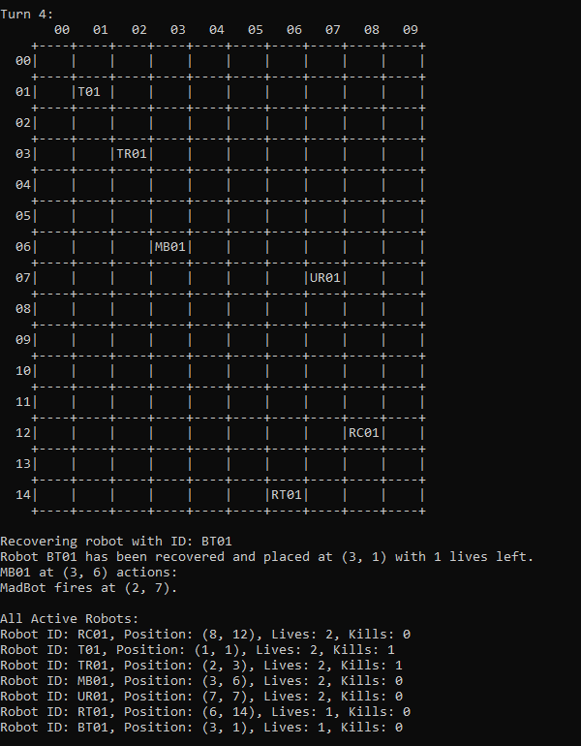

f. RoboTank: This robot does not move. It fires at one random location (x, y) in the battlefield, killing a robot if one exists in that position.
If RoboTank kills a total of 3 other robots, it will be upgraded to UltimateRobot.

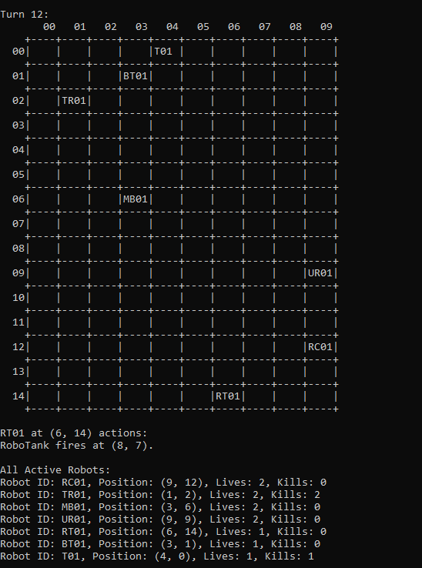

g. UltimateRobot: This robot moves like the TerminatorRoboCop, stepping and killing any robots on its path.
On top of that, in each turn, this robot fires randomly at 3 locations (x, y) in the battlefield.

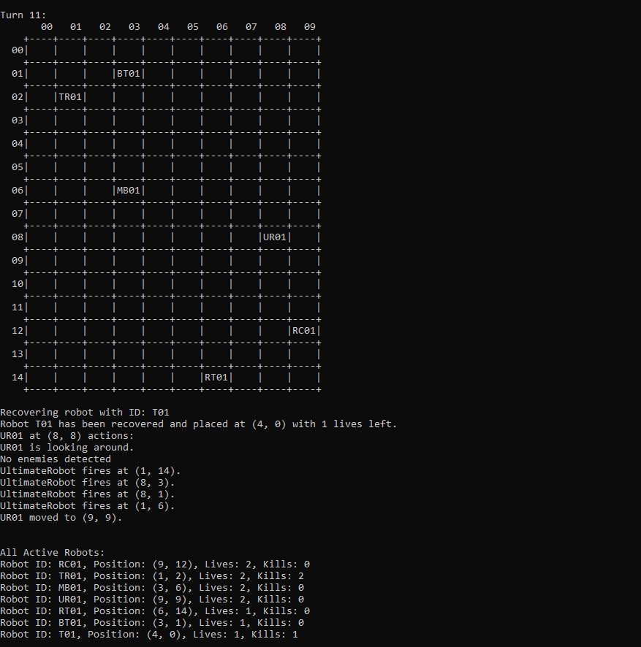

Q5. [8] Implementation of the required 7 robot classes with OOP concepts +1 or I&P&OO -3

Inheritance, figures, explanations
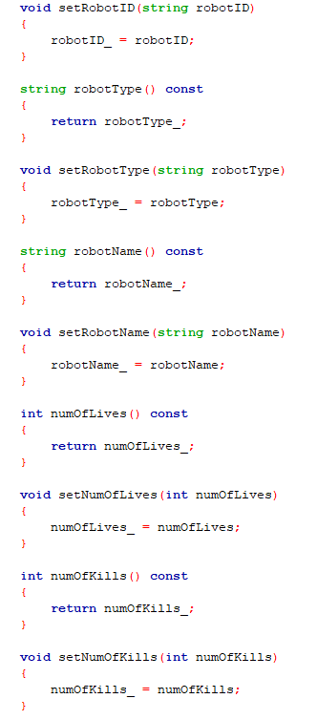
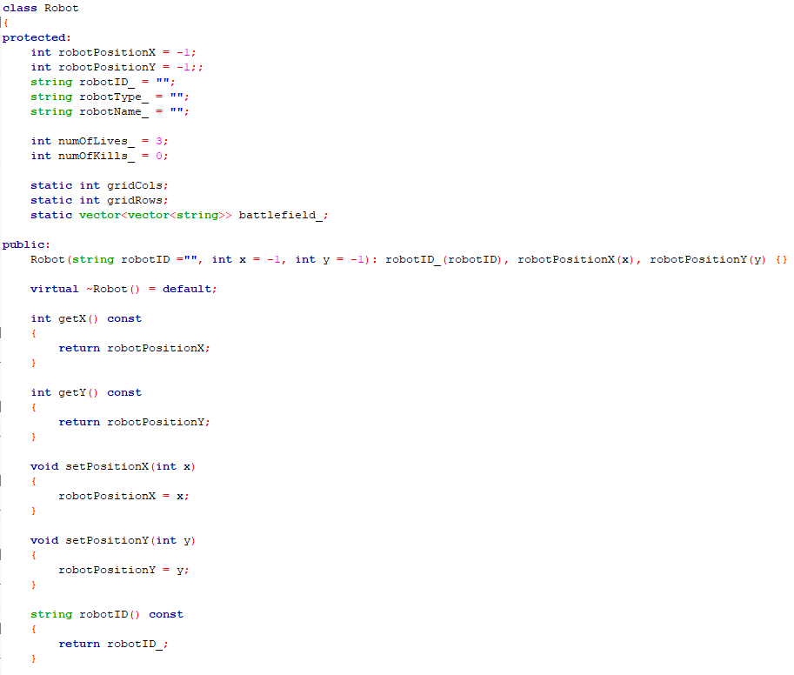
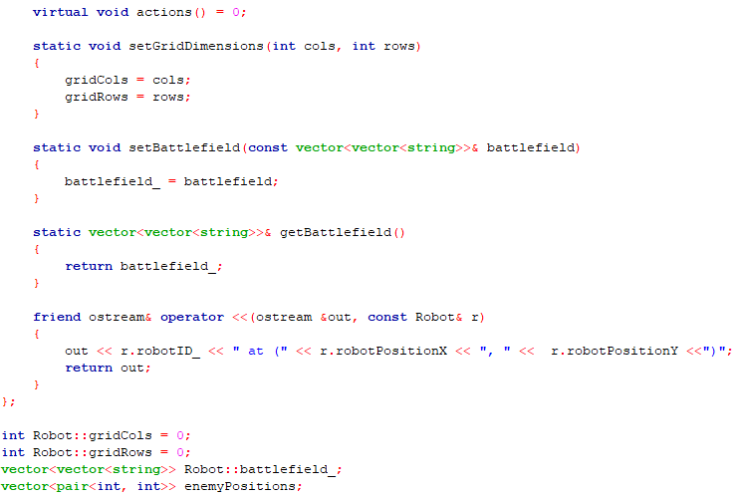

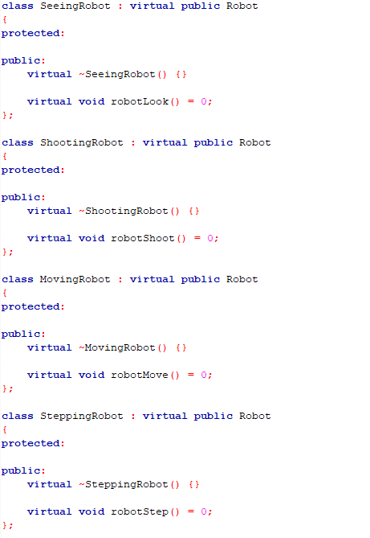
Robot class (grandparent) serves as the base class and is derived by SeeingRobot, ShootingRobot, MovingRobot and SteppingRobot (parents), which then is derived by each different types of robot classes.

Polymorphism, figures, explanations
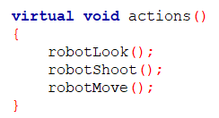
Operator overloading, figures, explanations

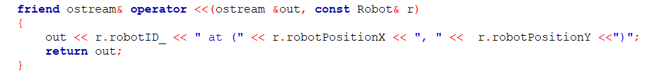

Screenshots (inputs, outputs), figures, explanations
a. RoboCop
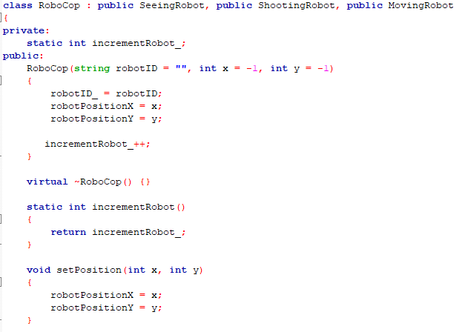

b. Terminator
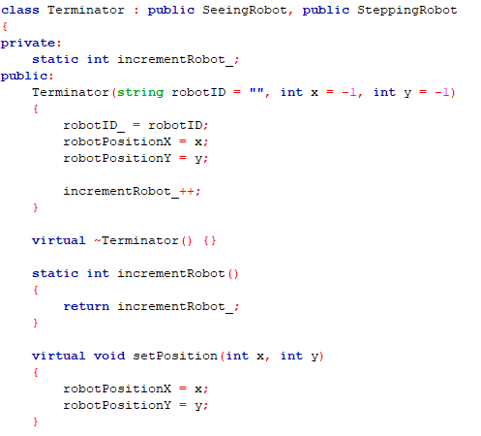

c. TerminatorRoboCop
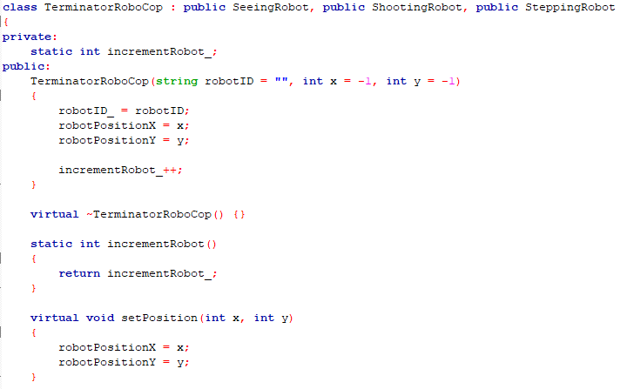
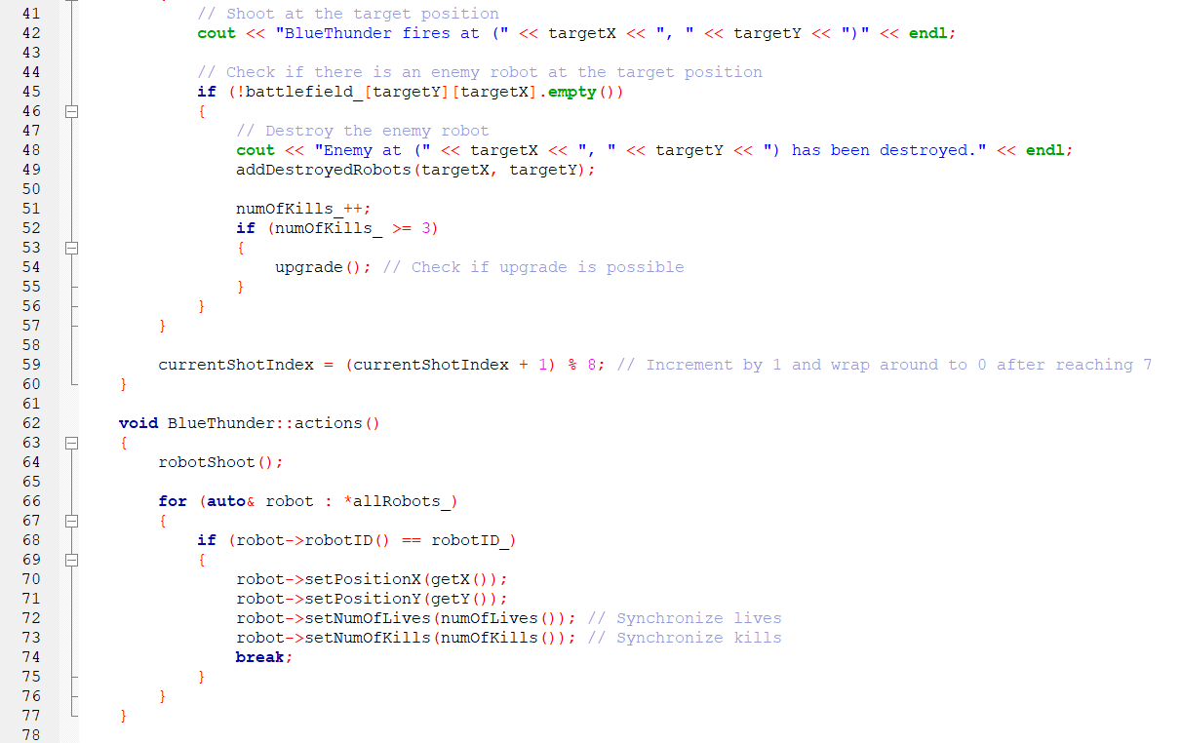
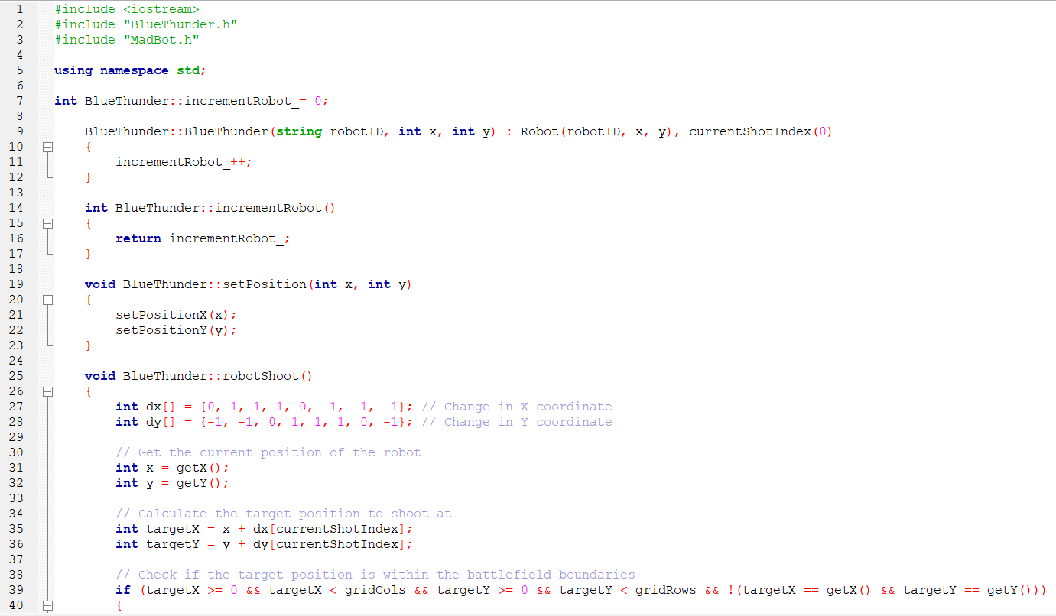
d. BlueThunder

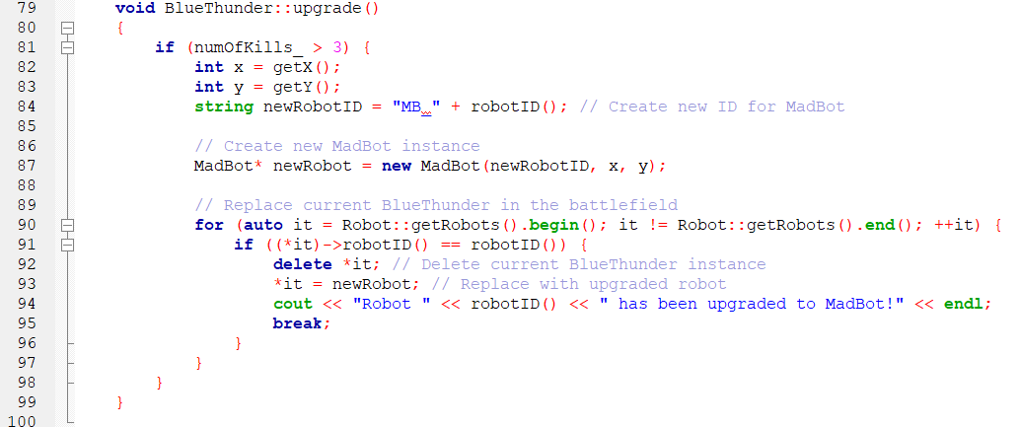

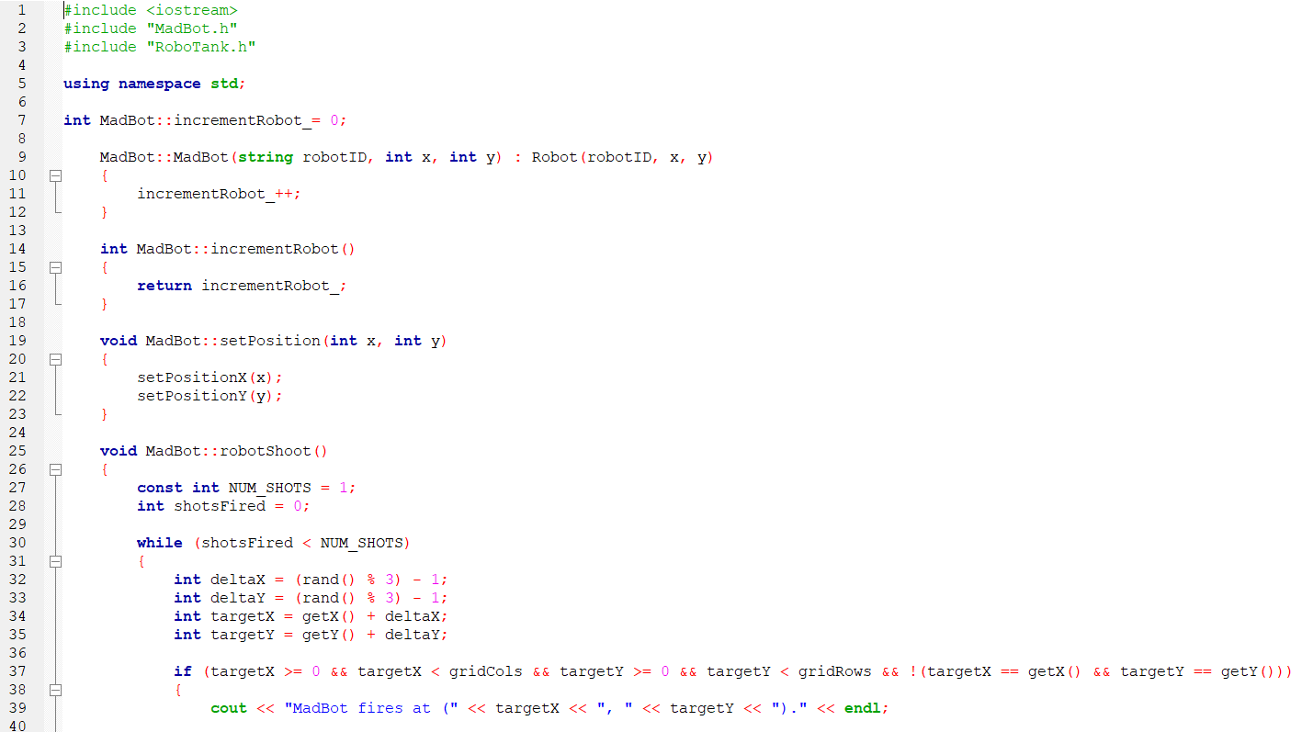
e. Madbot

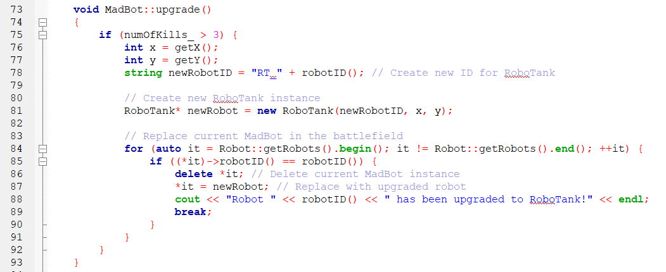
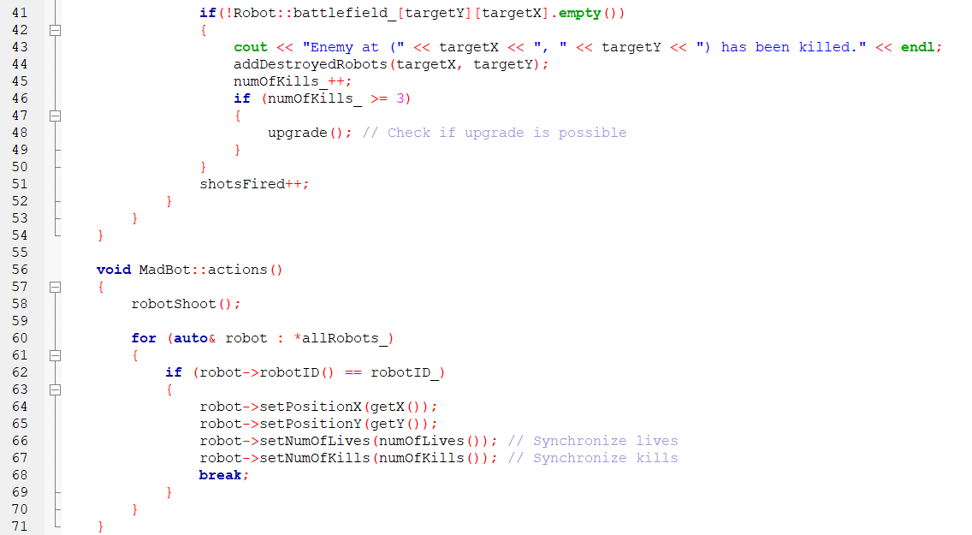

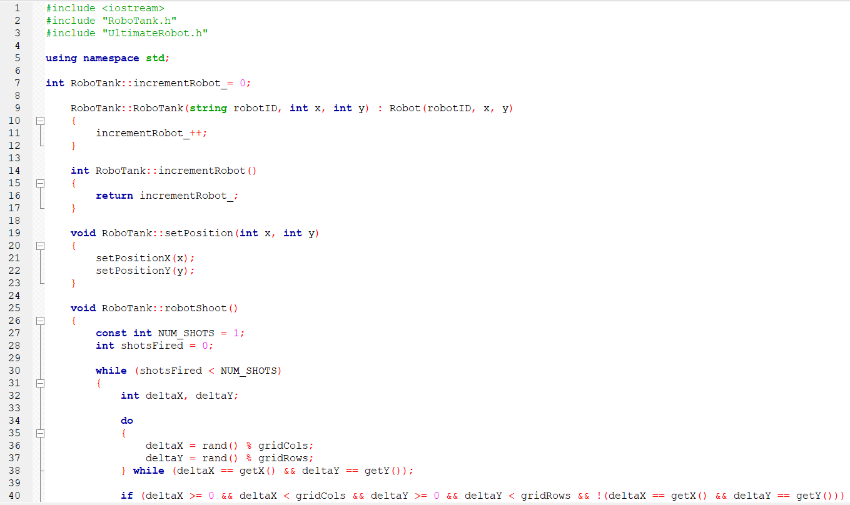
f. RoboTank
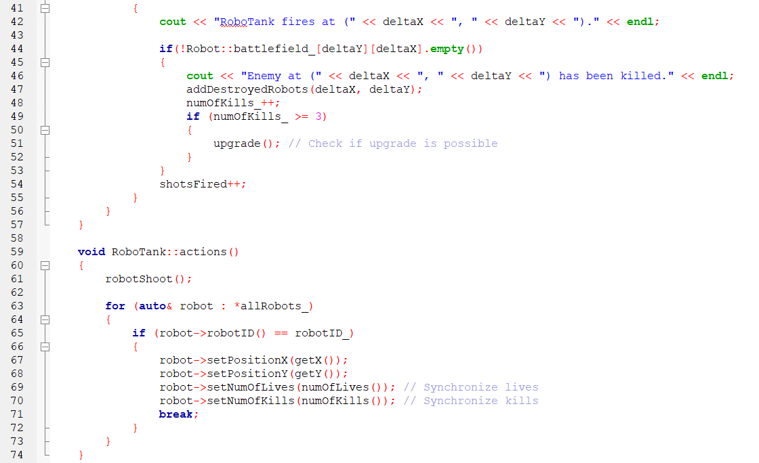

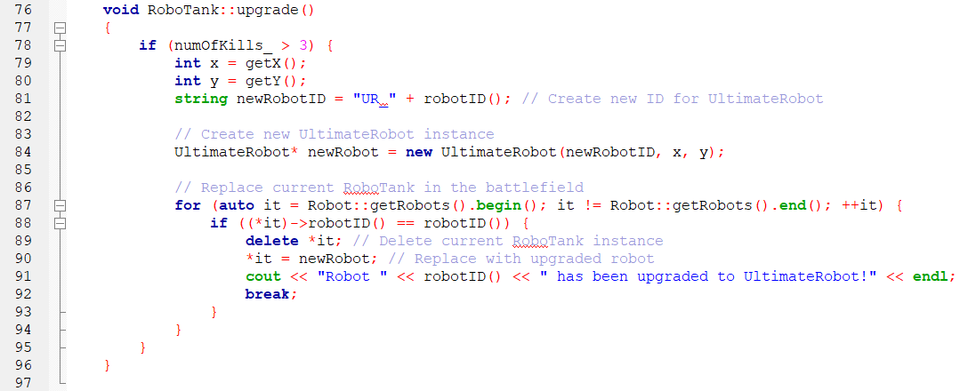

g. UltimateRobot

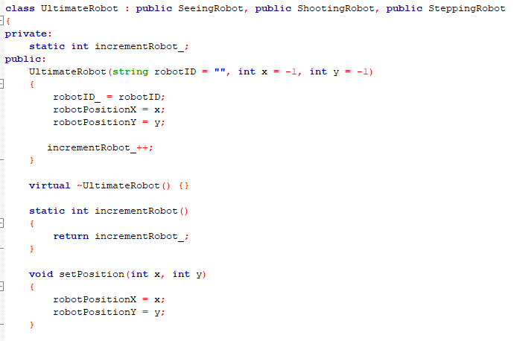

RoboCop  Pseudocode | BEGIN  READ RoboCop.h  READ TerminatorRoboCop.h  SET incrementRobot to 0  BUMP incrementRobot  SET robot position (x, y)  DEFINE foundEnemy to false  FOR loop through the neighbouring cells  LOOP dx for outer part iterates over -1 to 1  LOOP dy for inner part iterates over -1 to 1  IF both dx and dy equals to 0  CONTINUE to next iteration  END-IF  CALCULATE newX and newY  IF target is within the battlefield boundaries  IF enemy robot is at the target position  THEN print enemy robot position message  ADD to enemyPositions queue  SET foundEnemy equals true  END-IF  END-IF  IF enemy is not found  PRINT no enemies detected message  END-IF  END-FOR  SET maximum distance equals to 10  SET number of shots equals to 3  SET shotsFired equals to 0  WHILE shotsFired < number of shots  COMPUTE deltaX as random numbers between -10 and 10  COMPUTE deltaY as random numbers between -10 and 10  IF target is within the battlefield boundaries  THEN print RoboCop fires message  END-IF  IF enemy robot is at the target position  THEN print enemy robot position message  CALL addDestroyedRobots()  INCREMENT number of kills  END-IF  IF num of kills > 3  THEN check if upgrade is possible  CALL upgrade()  END-IF  INCREMENT shotsFired  END-WHILE  DO  SET newX and newY with generated random numbers between -1 and 1  WHILE newX and newY still within the range and battlefield [newX][newY] is empty  REMOVE the old position on the battlefield grid  SET robot new position  PRINT robotID has moved message  CALL robotLook(), robotShoot(), robotMove()  IF num of kills > 3  THEN check if upgrade is possible  CALL upgrade()  END-IF  FOR each robot in all robot  IF robot’s ID is equal to target robot ID  SET robot to desired X coordinate  SET robot to desired Y coordinate  SET robot’s number of lives to synchronized amount  SET robot’s number of kills to synchronized amount  END-IF  END-FOR  DETERMINE upgrade()  CALL upgrade()  SET TerminatorRoboCopCount = 0  FOR each robot in robots vector  IF is of type of TerminatorRoboCop  INCREMENT terminatorRoboCopCount  END-FOR  CREATE new instance for Terminator  FOR each robot in battlefield  IF robot ID for current robot matches current Robocop ID  THEN delete current Robocop instance  SET robot to newly upgraded robot  PRINT robot has been upgraded message  END-IF  END-FOR  END  BEGIN
Terminator  Pseudocode | BEGIN  READ Terminator.h  READ TerminatorRoboCop.h  SET incrementRobot to 0  BUMP incrementRobot  SET robot position (x, y)  DEFINE foundEnemy to false  PRINT robot ID is looking around message  FOR loop through to check the 8 neighbouring cells  LOOP dx for outer part iterates over -1 to 1  LOOP dy for inner part iterates over -1 to 1  IF both dx and dy equals to 0  CONTINUE to next iteration  END-IF  CALCULATE newX and newY  IF target is within the battlefield boundaries  IF enemy robot is at the target position  THEN print enemy robot position message  SET foundEnemy equals true  END-IF  IF enemy is not found  PRINT no enemies detected message  END-IF  END-FOR  INITIALISE newX and newY  IF enemyPositions is not empty  MOVE towards the first enemy position stored in enemyPosition  DELETE enemy position from the list  IF new position is not empty  PRINT robot ID stepped on another robot message  CALL addDestroyedRobots()  INCREMENT number of kills  END-IF  ELSE  DO  SET newX and newY with generated random numbers between -1 and 1  WHILE newX and newY still within the range and battlefield [newX][newY] is empty  END-IF  REMOVE the old position on the battlefield grid  SET robot new position  PRINT robotID has moved message  CALL robotLook(), robotStep()  IF num of kills > 3  THEN check if upgrade is possible  CALL upgrade()  END-IF  FOR each robot in all robot  IF robot’s ID is equal to target robot ID  SET robot to desired X coordinate  SET robot to desired Y coordinate  SET robot’s number of lives to synchronized amount  SET robot’s number of kills to synchronized amount  END-IF  END-FOR  DETERMINE upgrade()  CALL upgrade()  SET TerminatorRoboCopCount = 0  FOR each robot in robots vector  IF is of type of TerminatorRoboCop  INCREMENT terminatorRoboCopCount  END-FOR  CREATE new instance for Terminator  FOR each robot in battlefield  IF robot ID for current robot matches current Terminator ID  THEN delete current Terminator instance  SET robot to newly upgraded robot  PRINT robot has been upgraded message  END-IF  END-FOR  END  BEGIN
TerminatorRoboCop  Pseudocode | BEGIN  READ TerminatorRoboCop.h  SET incrementRobot to 0  INCREMENT incrementRobot when an instance is created  SET robot position (x, y)  INITIALIZE foundEnemy to false  DEFINE lookDistance as 1  SET startX to getX() - lookDistance  SET endX to getX() + lookDistance  SET startY to getY() - lookDistance  SET endY to getY() + lookDistance  FOR newX from startX to endX  FOR newY from startY to endY  IF newX == getX() AND newY == getY()  CONTINUE  IF newX is within gridCols AND newY is within gridRows  IF battlefield[newY][newX] is not empty  PRINT "Enemy detected at (newX, newY)"  SET foundEnemy to true  ADD (newX, newY) to enemyPositions  END-IF  END-IF  END-FOR  END-FOR  IF not foundEnemy  PRINT "No enemies detected"  END-IF  DEFINE MAX_DISTANCE as 10  DEFINE NUM_SHOTS as 3  SET shotsFired to 0  WHILE shotsFired < NUM_SHOTS  CALCULATE deltaX as random number between -MAX_DISTANCE and MAX_DISTANCE  CALCULATE deltaY as random number between -MAX_DISTANCE and MAX_DISTANCE  SET targetX to getX() + deltaX  SET targetY to getY() + deltaY  IF targetX is within gridCols AND targetY is within gridRows AND target is not current position  PRINT "TerminatorRoboCop fires at (targetX, targetY)"  IF battlefield[targetY][targetX] is not empty  PRINT "Enemy at (targetX, targetY) has been killed"  CALL addDestroyedRobots(targetX, targetY)  INCREMENT numOfKills  IF numOfKills >= 3  CALL upgrade()  END-IF  INCREMENT shotsFired  END-IF  END-WHILE  IF enemyPositions is not empty  SET newX to first enemy X position  SET newY to first enemy Y position  CLEAR enemyPositions  IF battlefield[newY][newX] is not empty  PRINT "TerminatorRoboCop stepped on another robot and destroyed it"  CALL addDestroyedRobots(newX, newY)  INCREMENT numOfKills  IF numOfKills > 3  CALL upgrade()  ELSE  DO  CALCULATE newX as getX() + random number between -1 and 1  CALCULATE newY as getY() + random number between -1 and 1  WHILE newX == getX() AND newY == getY() OR out of grid boundaries  END-IF  CLEAR old position on battlefield grid  SET new X position  SET new Y position  SET new position on battlefield grid to robotID  PRINT "TerminatorRoboCop moved to (newX, newY)"  CALL robotLook()  CALL robotShoot()  CALL robotStep()  FOR each robot in allRobots  IF robot’s ID equals current robotID  SET robot positionX to current X  SET robot positionY to current Y  SYNCHRONIZE robot’s number of lives  SYNCHRONIZE robot’s number of kills  BREAK loop  END-IF  END-FOR  IF numOfKills > 3  GET current coordinates (x, y) from getX() and getY()  CREATE new robot ID for UltimateRobot  CREATE new instance of UltimateRobot with newRobotID, x, y  FOR each robot in battlefield  IF robot ID matches current TerminatorRoboCop’s ID  DELETE current TerminatorRoboCop instance  REPLACE with new UltimateRobot instance  PRINT "Robot has been upgraded to UltimateRobot"  BREAK loop  END-IF  END-FOR  END-IF  END

BlueThunder Pseudocode | BEGIN  READ BlueThunder.h  SET incrementRobot to 0  BUMP incrementRobot  SET robot position (x, y)  DEFINE dx and dy as the change in X and Y coordinates  GET the current position of the robot  CALCULATE targetX and targetY to shoot at  IF target is within the battlefield boundaries  THEN print BlueThunder fires message  END-IF  IF enemy robot is at the target position  THEN print enemy robot position message  CALL addDestroyedRobots()  INCREMENT number of kills  END-IF  IF num of kills > 3  THEN check if upgrade is possible  CALL upgrade()  END-IF  INCREMENT robot shooting count  CALL robotShoot()  FOR each robot in all robot  IF robot’s ID is equal to target robot ID  SET robot to desired X coordinate  SET robot to desired Y coordinate  SET robot’s number of lives to synchronized amount  SET robot’s number of kills to synchronized amount  END-IF  END-FOR  DETERMINE upgrade()  IF num of kills>3  GET current coordinates (x,y) from getX() and getY()  SET new robot ID for MadBot  END IF  CREATE new instance for MadBot  FOR each robot in battlefield  IF robot ID for current robot matches current BlueThunder’s ID  THEN delete current BlueThunder instance  SET robot to newly upgraded robot  PRINT robot has been upgraded message  END-IF  END-FOR  END
MadBot Pseudocode | BEGIN  READ MadBot.h  SET incrementRobot to 0  BUMP incrementRobot  SET robot position (x, y)  SET number of shots to 1  SET shotsFired to 0  WHILE shotsFired < number of shots  COMPUTE deltaX as random numbers between -1 and 1  COMPUTE deltaY as random numbers between -1 and 1  SET targetX = getX() + deltaX  SET targetY = getY() + delta  IF target is within the battlefield boundaries  THEN print MadBot fires message  END-IF  IF enemy robot is at the target position  THEN print enemy robot position message  CALL addDestroyedRobots()  INCREMENT number of kills  END-IF  IF num of kills > 3  THEN check if upgrade is possible  CALL upgrade()  END-IF  INCREMENT shotsFired  END-WHILE  CALL robotShoot()  FOR each robot in all robot  IF robot’s ID is equal to target robot ID  SET robot to desired X coordinate  SET robot to desired Y coordinate  SET robot’s number of lives to synchronized amount  SET robot’s number of kills to synchronized amount  END-IF  END-FOR  DETERMINE upgrade()  IF num of kills>3  GET current coordinates (x,y) from getX() and getY()  SET new robot ID for RoboTank  END IF  CREATE new instance for RoboTank  FOR each robot in battlefield  IF robot ID for current robot matches current RoboTank’s ID  THEN delete current RoboTank instance  SET robot to newly upgraded robot  PRINT robot has been upgraded message  END-IF  END
RoboTank Pseudocode | BEGIN  READ RoboTank.h  SET incrementRobot to 0  BUMP incrementRobot  SET robot position (x, y)  SET number of shots to 1  SET shotsFired to 0  WHILE shotsFired < number of shots  DO  COMPUTE deltaX as random numbers within grid columns  COMPUTE deltaY as random numbers within grid rows  WHILE deltaX = getX and deltaY = getY  IF target is within the battlefield boundaries  THEN print RoboTank fires message  END-IF  IF enemy robot is at the target position  THEN print enemy robot position message  CALL addDestroyedRobots()  INCREMENT number of kills  END-IF  IF num of kills > 3  THEN check if upgrade is possible  CALL upgrade()  END-IF  INCREMENT shotsFired  END-WHILE  CALL robotShoot()  FOR each robot in all robot  IF robot’s ID is equal to target robot ID  SET robot to desired X coordinate  SET robot to desired Y coordinate  SET robot’s number of lives to synchronized amount  SET robot’s number of kills to synchronized amount  END-IF  END-FOR  DETERMINE upgrade()  IF num of kills>3  GET current coordinates (x,y) from getX() and getY()  SET new robot ID for UltimateRobot  END IF  CREATE new instance for UltimateRobot  FOR each robot in battlefield  IF robot ID for current robot matches current RoboTank’s ID  THEN delete current RoboTank instance  SET robot to newly upgraded robot  PRINT robot has been upgraded message  END-IF  END

UltimateRobot  Pseudocode | BEGIN  READ UltimateRobot.h  SET incrementRobot to 0  BUMP incrementRobot  SET robot position (x, y)  DEFINE dx and dy as the change in X and Y coordinates  robotLook:  GET the current position of the robot  FOR dx from -1 to 1  FOR dy from -1 to 1  IF dx == 0 AND dy == 0  CONTINUE  CALCULATE newX = getX() + dx  CALCULATE newY = getY() + dy  IF newX is within gridCols AND newY is within gridRows  IF battlefield[newY][newX] not empty  PRINT "Enemy detected at (newX, newY)"  ADD (newX, newY) to enemyPositions  END-IF  END-IF  END-FOR  END-FOR  SET NUM_SHOTS to 4  SET shotsFired to 0  WHILE shotsFired < NUM_SHOTS  DO  CALCULATE random deltaX within gridCols  CALCULATE random deltaY within gridRows  WHILE deltaX == getX() AND deltaY == getY()  IF deltaX within gridCols AND deltaY within gridRows  PRINT "UltimateRobot fires at (deltaX, deltaY)"  IF battlefield[deltaY][deltaX] not empty  PRINT "Enemy at (deltaX, deltaY) killed"  CALL addDestroyedRobots(deltaX, deltaY)  INCREMENT number of kills  END-IF  INCREMENT shotsFired  END-IF  END-WHILE  IF enemyPositions not empty  SET newX = first enemy X position  SET newY = first enemy Y position  REMOVE first enemy position from enemyPositions  IF battlefield[newY][newX] not empty  PRINT "UltimateRobot stepped on another robot and destroyed it"  CALL addDestroyedRobots(newX, newY)  ELSE  DO  CALCULATE newX = getX() + (random between -1 and 1)  CALCULATE newY = getY() + (random between -1 and 1)  WHILE newX == getX() AND newY == getY() OR out of grid boundaries  END-IF  CLEAR old position on battlefield grid  SET new X position  SET new Y position  SET new position on battlefield grid to robotID  PRINT "UltimateRobot moved to (newX, newY)"  actions:  CALL robotLook  CALL robotShoot  CALL robotStep  FOR each robot in all robots  IF robot’s ID is equal to target robot ID  SET robot to desired X coordinate  SET robot to desired Y coordinate  SET robot’s number of lives to synchronized amount  SET robot’s number of kills to synchronized amount  END-IF  END-FOR  END

Q6. [5] The algorithms used to optimize the actions of robots, optimize the two actions or -2

Algorithm 1 optimize the action ?1, figures, explanations
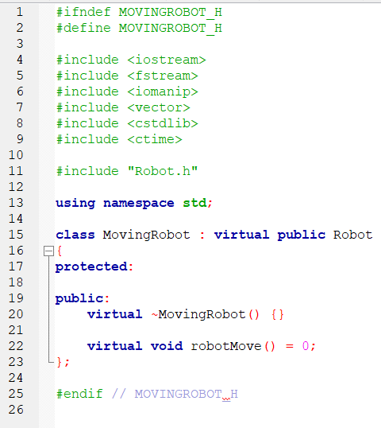

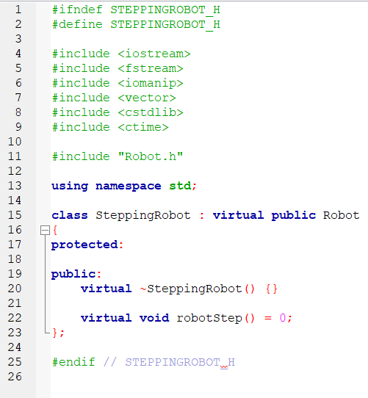
The code inherits from Robot.h. This code is used for robots that can move around, it provides an interface for moment behaviour.

The code inherits from Robot.h. This code is used for robots that can step around, it provides an interface for stepping behaviour.
Algorithm 1 screenshots (inputs, outputs), explanations
?

Algorithm 1 code segments, pseudocode parts, explanations

Robot Pseudocode | BEGIN  READ Robot.h  READ Battlefield.h  READ Robocop.h  READ Terminator.h  READ TerminatorRoboCop.h  READ BlueThunder.h  READ MadBot.h  READ RoboTank.h  READ UltimateRobot.h  INITIALISE robot ID, X and Y  RETURN robotPositionX  RETURN robotPositionY  SET the robot’s X position  SET the robot’s Y position  RETURN robot ID  SET robot ID  RETURN robot’s type  SET the robot’s type  RETURN robot’s name  SET robot’s name  RETURN robot’s number of lives  SET robot’s number of lives  DECREASE robot's number of lives  RETURN robot's number of kills  SET robot’s number of kills  SET the grid dimensions for the battlefield  SET the battlefield grids  RETURN the battlefield grids  SET pointer to the vector of the robots in the battlefield  SET pointer to the vector of all robots  RETURN the reference of the vector of the robots in the battlefield  RETURN the reference of the vector of all robots  FOR each robots in all robots  IF robot’s position matches x and y coordinates  SET battlefield_[y][x] to empty space  DECREMENT robot’s lives  END-IF  IF the robot has any lives still remaining  ADD robot ID to waitingRobots queue  PRINT robot added to queue message  ELSE  PRINT robot has been permanently destroyed  ADD robot ID to destroyedRobots queue  END-IF  UPDATE corresponding robots in allRobots_  DELETE the robot from robots_  END-FOR  WHILE waitingRobots queue is not empty  GET robot ID from the queue  DELETE the robot ID from the queue  PRINT recovering robot ID message  FOR each robot in allRobots_  IF robot ID matches  FIND a random empty position on the battlefield  SET the recovered robot’s position to the new position  ADD the recovered robot back to the robots vector  UPDATE battlefield_ with robot ID  PRINT robot has been recovered message  ELSE  PRINT robot cannot be recovered message  END-IF  END-FOR  END-WHILE  INITIALISE grid columns to 0  INITIALISE grid row to 0  INITIALISE empty battlefield to 2D vector  INITIALISE robots to nullptr  INITIALISE allrobots to nullptr  INITIALISE destroyedRobots to an empty queue  INITIALISE waitingRobots to an empty queue  END

Algorithm 2 optimize the action ?2, figures, explanations
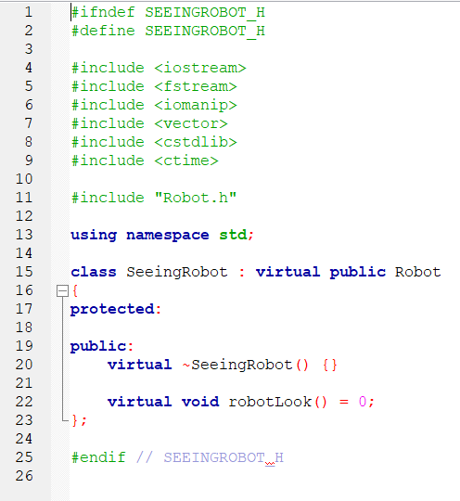

The code inherits from Robot.h. This code is used for robots that can see around, it provides an interface for looking behaviour.

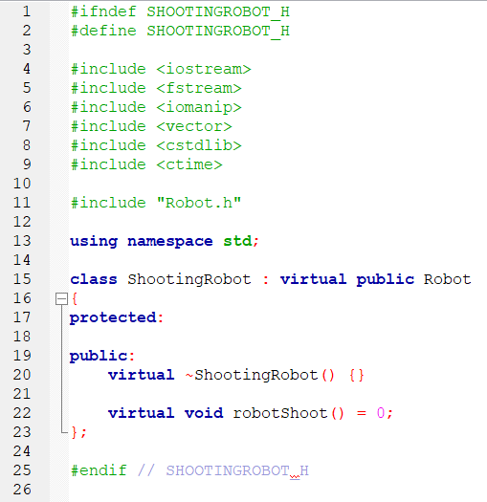
The code inherits from Robot.h. This code is used for robots that shoot, it provides an interface for shooting behaviour.

Algorithm 2 screenshots (inputs, outputs), explanations
?

Algorithm 2 code segments, pseudocode parts, explanations

Q7. [5] Design and implementation of data structures, linked list and queues or -2

Linked list: keep track robot actions during the simulation, figures, explanations
?

Linked list: screenshots (inputs, outputs), figures, explanations
?

Linked list: code segments, pseudocode parts, explanations

Linked List  Pseudocode | BEGIN  DESTRUCTOR LinkedList::~LinkedList:  WHILE head is not NULL  SET temp to head  SET head to head->next  DELETE temp  END-WHILE  END DESTRUCTOR  METHOD LinkedList::addNode(type, id, x, y):  CREATE newNode as a new Node with parameters type, id, x, y  IF head is NULL  SET head and tail to newNode  ELSE  SET tail->next to newNode  SET tail to newNode  END-IF  END METHOD  METHOD LinkedList::printList:  SET current to head  PRINT "LinkedList:"  WHILE current is not NULL  PRINT "Robot " + current->robotType + " " + current->robotID + " at (" + current->posX + "," + current->posY + ")"  SET current to current->next  END-WHILE  END METHOD  END

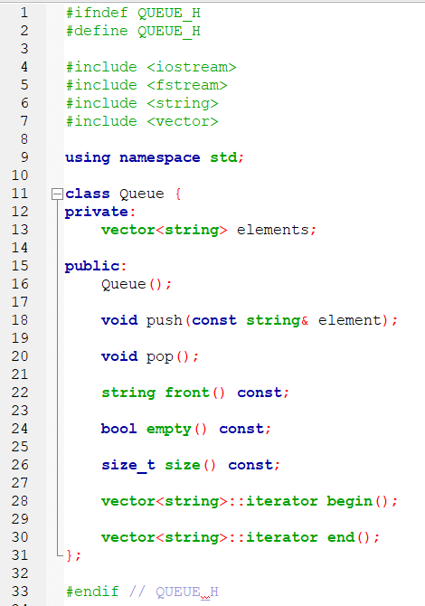
Two queues: keep track of the respective destroyed and waiting robots, figures, explanations
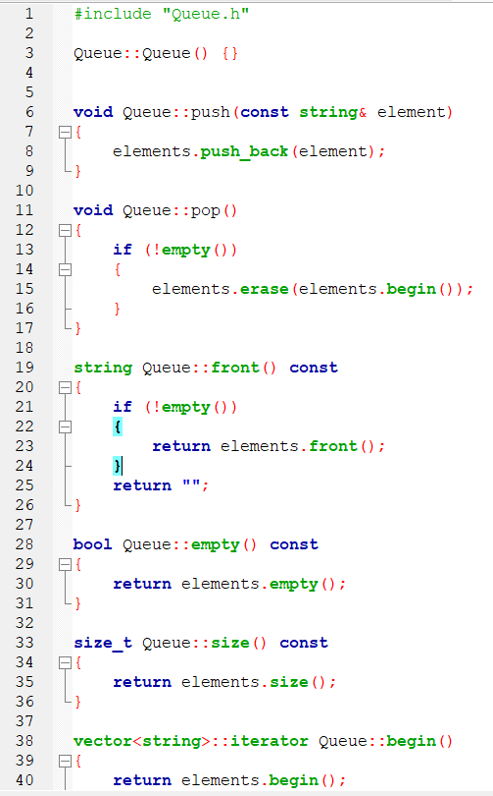

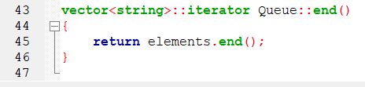

Queues: screenshots (inputs, outputs), figures, explanations

Queues: code segments, pseudocode parts, explanations

Queue Pseudocode | BEGIN  READ Queue.h  INITIALISE empty vector named elements  FUNCTION push()  ADD elements to the end of the vector  END-FUNCTION  FUNCTION pop()  IF elements is not empty  DELETE the first element of the vector  END-IF  END-FUNCTION  FUNCTION front()  IF elements is not empty  RETURN the first element of the vector  ELSE  RETURN an empty string  END-IF  END-FUNCTION  FUNCTION empty()  RETURN true if vector is empty  RETURN false if otherwise  END-FUNCTION  FUNCTION size()  RETURN the size of the element  END-FUNCTION  FUNCTION begin()  RETURN an iterator to the beginning of the element  END-FUNCTION  FUNCTION end()  RETURN an iterator to the end of the element  END-FUNCTION  END

Question: How to compile, how to run the program

